BANTAM ZONING BOARD OF APPEALS
890 Bantam Road, Bantam, CT 06750

Agenda January 11, 2024

1. Call to Order
2. Approval of Previous Minutes
a. November 9, 2023
3. Old Business
a. New Members
4. New Business
5. Applications
6. Public Comment
7. Adjourn

Attest:

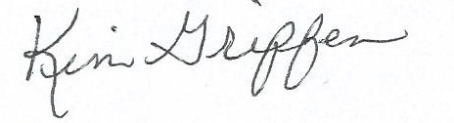
Kim Griffen
Clerk

