BANTAM ZONING BOARD OF APPEALS
890 Bantam Road, Bantam, CT 06750

Agenda March 14 , 2024

1. Call to Order
2. Approval of Previous Minutes
a. January 12, 2024
3. Old Business
a. New Members
4. New Business
5. Applications
6. Public Comment
7. Adjourn

Attest:

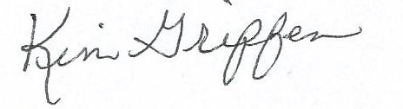
Kim Griffen
Clerk

