Regular ZBA Meeting Minutes
7:00 pm
January 11, 2024
1. Call to Order :
Paul Griffen called the meeting to order at 7: 00 pm
Members: Rene MacKenzie, Brian White and Kim Griffen (clerk) Absent: Sam Wolf, and Lauren Sage.

2. Approval of Minutes- A motion to approve the minutes from
November 9, 2023 made by Rene' and 2nd made by Brian. Motion carried unanimously.

3. Old Business-
a. New Members Needed

4. New Business- Paul informed the board members that an on line class will be needed for members as a state qualification. Paul will check on the link to send to members.

5. Applications- None

6. Public- None

7. Adjournment-motion to adjourn at 7:05 pm made by Rene and 2nd by Brian. Motion carried unanimously.

Attest:

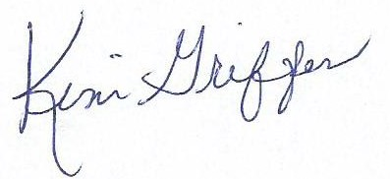Kim Griffen Bantam Borough ZBA Clerk

