Regular ZBA Meeting Minutes
7:00 pm
May 9, 2024

The regular meeting of the Zoning Board of Appeals wasn't held due to lack of quorum.

Attest:
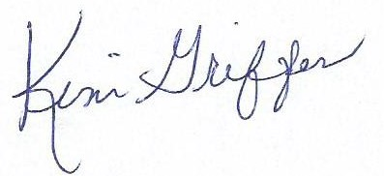
Bantam Borough ZBA Clerk

