Bantam Board of Warden & Burgesses
Agenda
4-08-26
The regular monthly meeting of the Borough of Bantam Warden & Burgesses will be held on April 8, 2026 at 7:00 p.m. at The Bantam Borough Hall.

- Previous Minutes:
- Treasurers Report:
- Old Business:
a. Bantam Annex
b. Members Needed
4. Public Input and Correspondence:
5. New Business
- Any Other Business
Discuss Budget

Attest:

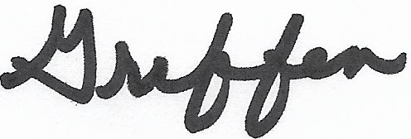
Kim Griffen, clerk
•

Borough of Bantam

